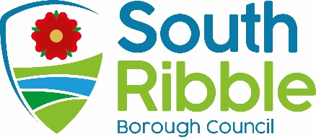

Report of | Meeting | Date
Director of Finance and Section 151 Officer | Governance Committee | Tuesday, 6th February 2024

Statement of Accounts 2022/23

Is this report confidential? | No

Is this decision key? | No

Savings or expenditure amounting to greater than £100,000 | Significant impact on 2 or more council wards

Purpose of the Report

- Further to the approval of the Draft Statement of Accounts for 2022/23 at the Governance Committee meeting on 28th November 2023, the purpose of the report is to update Committee Members on the adjustments made to the accounts since that date, following completion of the external audit by Grant Thornton.

Recommendations

- Further to the approval of the Draft 2022/23 Statement of Accounts at the Governance Committee on 28th November 2023, the Committee is asked to approve the statements which have been amended during the completion of the external audit to include the adjustments detailed in point 12 below.

Reasons for recommendations

- At the November Governance Committee meeting, the Committee approved the 2022/23 Statement of Accounts, subject to any amendments which, in the opinion of the Director of Finance (Section 151 Officer), were minor in nature.

- Delegated authority was given to the Director of Finance, in consultation with the Chair of Governance Committee, to make such minor amendments, however if in the opinion of the Director of Finance any such amendments were found to be material to the financial position of the council, then Governance Committee would be asked to approve the updated Statement of Accounts.

Other options considered and rejected

- The Statement of Accounts are prepared in the form to meet professional accounting standards and to comply with statutory regulations. There are therefore no alternative options that can be adopted. The report complies with the recommendations approved by Governance Committee in November 2023.

Corporate priorities

- The report relates to the following corporate priorities:

An exemplary council | Thriving communities
A fair local economy that works for everyone | Good homes, green spaces, healthy places

Background to the report

- Once the external audit has been completed, the Regulations specify that the responsible Financial Officer must reconfirm on behalf of the authority that they are satisfied that the Statement of Accounts present a true and fair view of the financial position of the authority at the year end, and the income and expenditure for the year.

- The council is then required to:
- consider, either by way of a Committee, or by the Members meeting as a whole, the Statement of Accounts;
- approve the Statement of Accounts by a resolution of that Committee or meeting.

- South Ribble Borough Council delegates the responsibility for the approval of the accounts to the Governance Committee.

- The Governance Committee approved the Draft 2022/23 Statement of Accounts at their meeting on 28th November 2023, subject to any amendments identified in the completion of the external audit which, if in the opinion of the Director of Finance were material to the financial position of the Council, the Governance Committee would be asked to approve the updated Statement of Accounts at a future meeting.

- As noted in Grant Thornton’s Audit Findings Report on the agenda, they have now completed their audit work. In doing so, since 28th November they have identified 4 adjustments required to the accounts which they have discussed with the Director of Finance and her team; these amendments have been agreed and the 2022/23 Statement of Accounts updated accordingly.

- The full list of adjustments identified by Grant Thornton to the Draft Statement of Accounts published on 14th August 2023 are set out below; this can also be found in Appendix D of the Audit Findings Report.

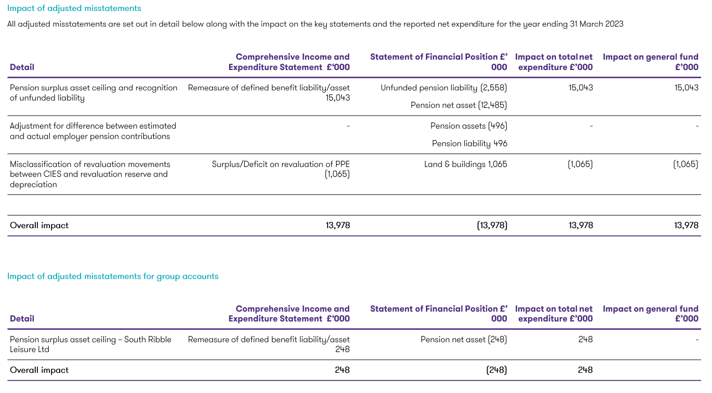

- In relation to each of the points above;

- The first two adjustments to the council’s accounts and the one adjustment to the group accounts relate to accounting for the pension for both South Ribble Council and its wholly owned subsidiary, South Ribble Leisure Ltd. Accounting for pensions was unusual in 2022/23 due to there being a net surplus on the respective fund; this position was not unique to South Ribble. The fund actuaries were requested to provide an IFRIC 14 assessment which considered the limit to be placed on this defined benefit asset. This was the approach taken by many local authorities across the country who found themselves in the same position. At the time of preparing the accounts it was uncertain how this surplus should be treated. Following the IFRIC 14 Assessment in November 2023, and on advice from the technical team at Grant Thornton, adjustments were identified and actioned in line with the advice received.

- The third adjustment to the council’s accounts relates to Property, Plant and Equipment (PPE) and the incorrect use of the revaluation reserve, rather than the Comprehensive Income and Expenditure Statement (CIES) following an adjustment to the council’s asset register. This has been reviewed and additional checks and balances put in place to ensure correct accounting for 2023/24 and beyond.

- Misclassification and disclosure changes have been made to the accounts as outlined in page 34 of Grant Thornton’s Audit Findings Report.

- 2 adjustments identified by the auditors that have not been actioned as they are not material to the accounts are detailed on page 35 of the Audit Findings Report:

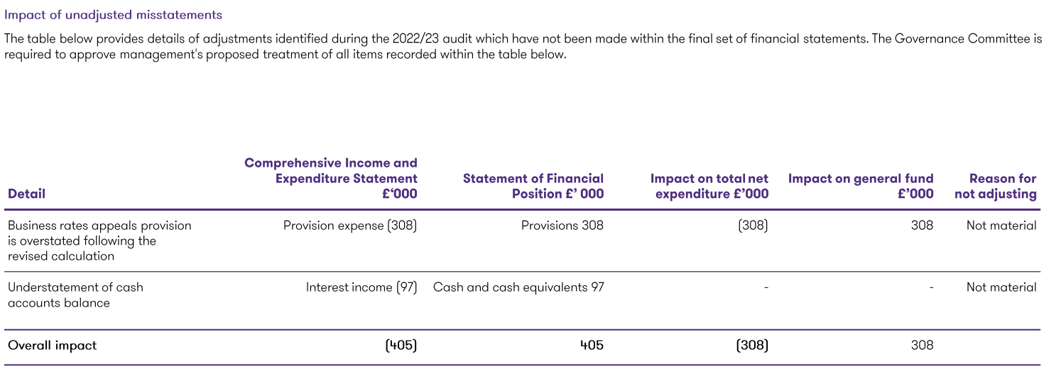

- Having considered the position, the council have decided not to adjust for these items as they are not material to the overall position of the accounts. The Provision for Business Rates appeals is reviewed annually and the provision for 2023/24 will be calculated using the methodology that resulted in the revised figure above. The interest income referred to above will be included within the 2023/24 accounts, and new approaches to treasury management and reconciliations that have now been introduced will ensure that such an understatement is not an issue for 23/24. This unadjusted misstatement is referred to in the Letter of Representation to be signed by the Chair of the Governance Committee and the Director of Finance

- The Annual Governance Statement is unchanged from that approved by the Committee on 23 May 2023

Climate change and air quality

- The work noted in this report does not impact the climate change and sustainability targets of the Councils Green Agenda and all environmental considerations are in place.

Equality and diversity

- This report has no implications in respect of equality and diversity.

Risk

- The accounts must be compliant with the relevant standards and must be prepared on a true and fair view basis. Failure to comply could result in a failure to meet the statutory duty.

Comments of the Statutory Finance Officer

- The report meets the statutory accounting requirements for the Statement of Accounts to be produced, which must present a factual statement of the income and expenditure flows over the course of the 2022/23 financial year, and a snapshot of the Balance Sheet position as at 31st March 2023.

- All financial implications relating to the final budget outturn position have been set out in the Revenue and Capital Outturn Reports 2022/23, and which were considered by Cabinet on 21st June 2023.

Comments of the Monitoring Officer

- The legal implications are in respect of the Accounts and Audit Regulations 2015 (as amended) 2022, and the requirement that the Accounts must be compliant with the relevant Accounting Standards and Codes of Practice and must be prepared on a true and fair view basis. Failure to comply could result in a failure to meet the statutory duty.

Background documents

- Accounts and Audit (England) Regulations 2015 (as amended) 2022
- CIPFA Code of Practice on Local Authority Accounting in the United Kingdom 2022/23.

Report Author: | Email: | Telephone: | Date:
Jean Waddington (Principal Financial Accoutant) | jean.waddington@chorley.gov.uk | 01257 515151 | 30.1.24

